**UNIVERSIDAD TECNOLÓGICA DE PANAMÁ**

**FACULTAD DE INGENIERÍA DE SISTEMAS COMPUTACIONALES**

**LICENCIATURA EN INGENIERÍA DE SISTEMAS DE INFORMACIÓN**

**SISTEMAS DE BASES DE DATOS II**

**Asignación #3**

**Estudiante:**

**JOSÉ QUINTERO 8-952-698**

**DOCENTE: ING. HENRY J. LEZCANO P.**

**GRUPO: 1IF121**

**FECHA: 14 SEPTIEMBRE.**

**AÑO 2020.**

**Problema 1**

create table Students(

ID number(4) not null,

first_name varchar2(50) not null,

last_name varchar2(50) not null,

major varchar2(50) not null

);

insert into Students values(1111,'Federico','Escobar','Informatica');

insert into Students values(2222,'Rayan','Torrero','Negocios');

insert into Students values(3333,'Jose','Castro','Psicologia');

insert into Students values(4444,'Mario','Bros','Communicacion');

insert into Students values(5555,'Force','Link','Informatica');

NOTA: Por problemas con el Oracle en mi pc opte por usar el live Oracle para ir creando el código y es por es por eso que algunas veces las imágenes serán del live Oracle y otra veces será en el cmd que un compañero compilo por mi ya que el live de Oracle no “Aguanta” algunos comandos DDL y DCL

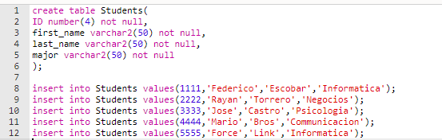

**Cursor**

Declare

v_StudentID students.ID%type;

v_FirstName students.first_name%type;

v_LastName students.last_name%type;

v_Major students.major%type:='Computer Science';

CURSOR c_Students is

SELECT id, first_name, last_name

From students

where major=v_Major;

Begin

Open c_Students;

LOOP

FETCH c_Students INTO v_StudentID, v_FirstName, v_LastName;

EXIT WHEN c_Students%NOTFOUND;

END LOOP;

CLOSE c_Students;

END;

/

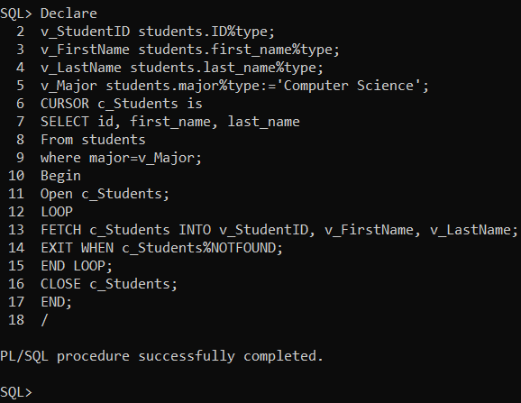

Problema 2

DECLARE

v_RoomID classes.room_id%TYPE;

v_Building rooms.buliding%TYPE;

v_Department classes.department%TYPE;

v_Course classes.course%TYPE;

CURSOR c_Building IS

SELECT building

FROM rooms, classes

WHERE rooms.room_id = classes.room_id

AND department = v_Department

AND course = v_Course;

BEGIN

v_Department := ‘HIS’;

v_Course _= 101;

OPEN c_Building;

v_Department := ‘XXX’;

v_Course := -1;

END;

/

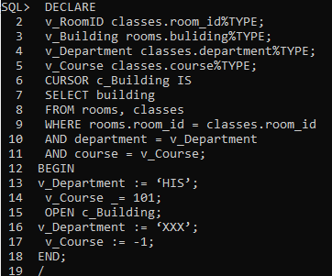

Problema 3

DECLARE

CURSOR c_building (v_RoomID classes.room_id%TYPE;

v_Building rooms.buliding%TYPE;

v_Department classes.department%TYPE;

v_Course classes.course%TYPE) IS

SELECT building

FROM rooms, classes

WHERE rooms.room_id = classes.room_id

AND department = v_Department

AND course = v_Course;

BEGIN

OPEN c_building (‘HIS’,101);

END

/

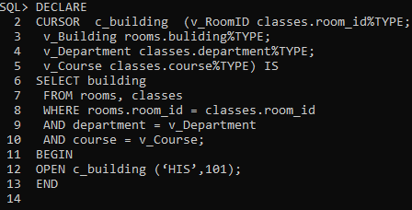

Problema 4

create table temp_tabla(

columnaC varchar2(50),

columnaN varchar2(50));

set serveroutput on;

Declare

v_roomdata rooms%ROWTYPE;

Begin

select * into v_roomdata

from rooms

where room_id='-1';

if SQL%NOTFOUND THEN

Insert into temp_tabla(columnaC) values('NOT FOUND')

end if;

exception

when NO_DATA_FOUND THEN

INSERT INTO temp_tabla(columnaC) values('NOT FOUND, EXCEPTION HANDLER');

END;

/

select*

from temp_tabla;

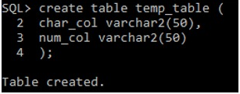

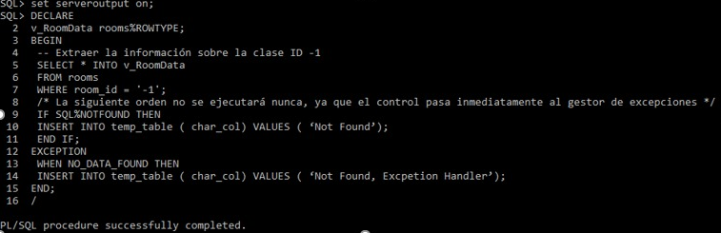

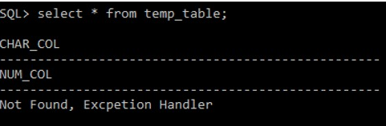

Problema 5

Problema 6

create table manga(

idManga number primary key not null,

nombre varchar2(20),

autor varchar2(20)

);

Insert into manga values(12,'HOTD','Hatake Minato');

Insert into manga values(01,'Naruto',' Fashi,');

Insert into manga values(25,'Bossy President','ICiyuan dongman');

Insert into manga values(177,'Dao Yin','Chaos');

Insert into manga values(88,'Versatile Mage','Quanzhi');

Set serveroutput ON;

DECLARE

vnombre VARCHAR2(20);

unombre VARCHAR2(20) := 'hotd' ;

CURSOR obtener(pnombre VARCHAR2) IS

SELECT idManga,nombre,autor

FROM manga

WHERE nombre = pnombre;

manga_rec obtener%ROWTYPE;

BEGIN

vnombre := '&vnombre';

DBMS_OUTPUT.PUT_LINE ('Usted desea Actualizar el manga: ' || vnombre);

FOR manga_rec IN obtener(vnombre) LOOP

DBMS_OUTPUT.PUT_LINE('Manga id: '||manga_rec.idManga|| ' Autor: ' || manga_rec.autor);

IF obtener%found THEN

UPDATE manga

SET nombre = unombre

WHERE idManga = manga_rec.idManga;

ELSE DBMS_OUTPUT.PUT_LINE('no existe');

END IF;

END LOOP;

COMMIT;

END;

